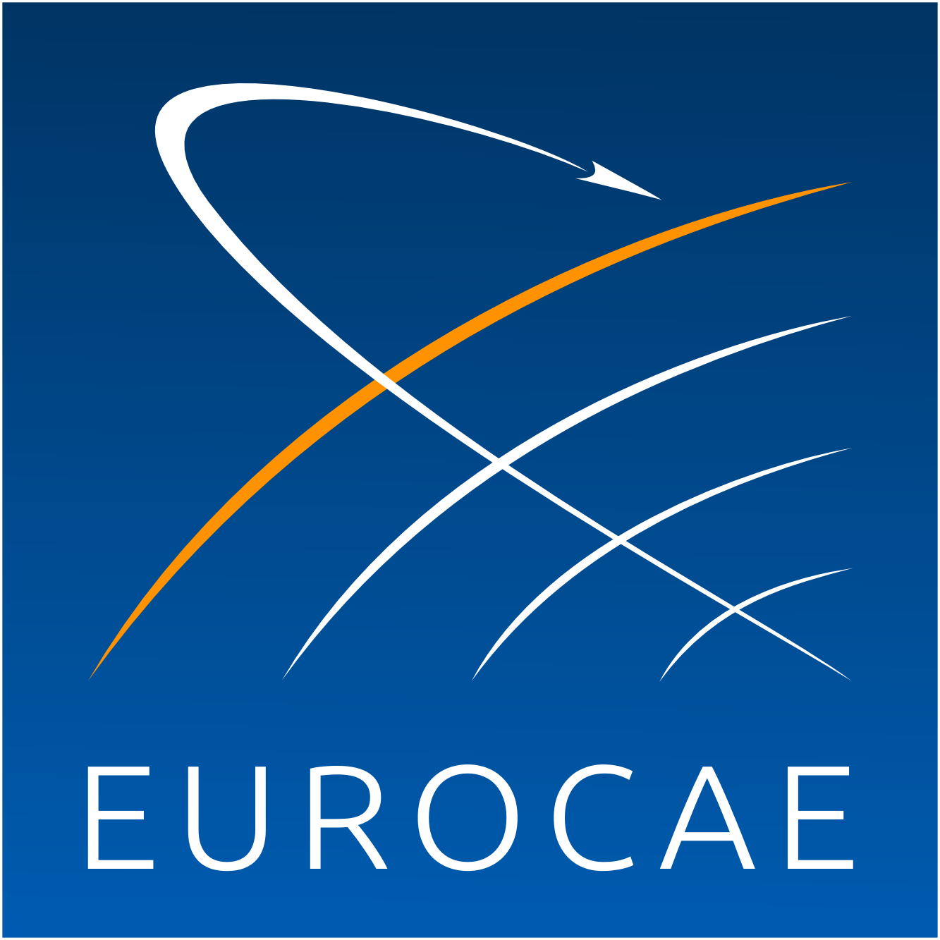

The European Organisation for Civil Aviation Equipment

L’Organisation Européenne pour l’Equipement de l’Aviation Civile

EUROCAE WG-88
“On-board Weight and Balance Systems”

Call for Participation*

*EUROCAE requires membership to follow Working Group activities.
For information please consult: http://eurocae.net/about-us/working-groups/

Firm or Organisation:

- Will your firm or organisation participate? YES NO

Designated representative(s):

Name:
Address:

Tel.: Fax.:
Email:

Will attend as: - Active Member YES NO
- Observer YES NO

Possible comments:
………………………………………………………………………………………………………………..………

Name:
Date:
Signature:

To be returned to EUROCAE Secretariat by 20 October 2017

by e-mail to Adrian.Cioranu@eurocae.net

